**Test plan**

Members:

Govinda

Melese

Ruth

Juarni

Wenhua

Shuying

Contents

Introduction 3

Fig: Test Image A 4

Fig: Test Image B 5

Fig: Test Image C 5

Maximized View of crossing 6

Description: 7

Test Action 7

Add crossing 8

Remove crossing 8

Stop Simulation 8

Maximize 8

Adjust Traffic 9

Save Simulation 9

Open Simulation 9

New 10

Exit 10

Start simulation 11

# Introduction

This test plan will be in charge to do the acceptance testing where the features Functionality, Usability and application reliability will be checked. The technical testing plan will not delivered with this project as our high skilled system. Testing department do the testing extensively.

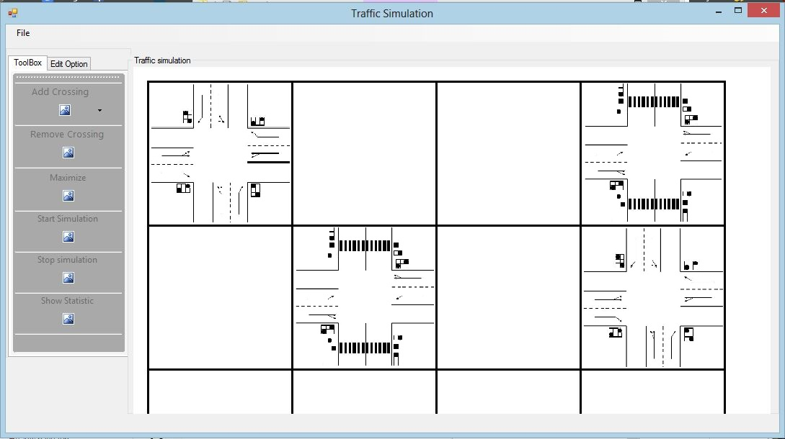

# Fig: Test Image A

## Fig: Test Image B

OK

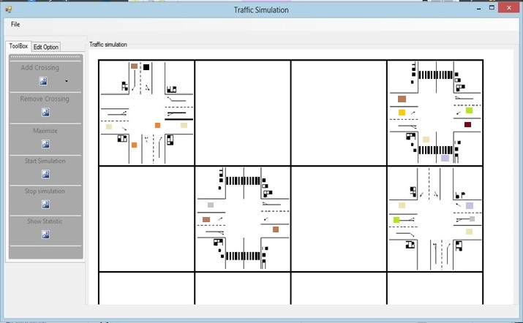

# Fig: Test Image C

# Maximized View of crossing

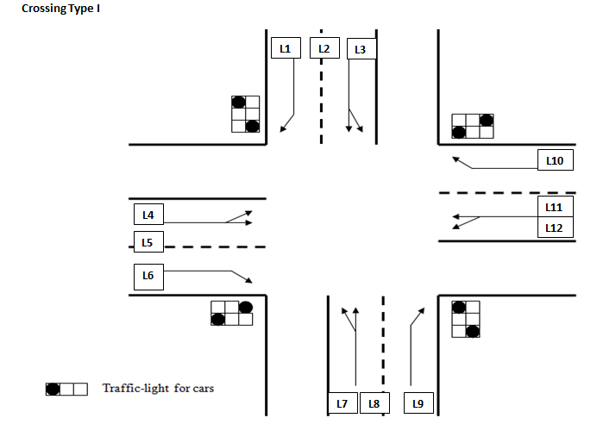

In cell 1st row 1st column

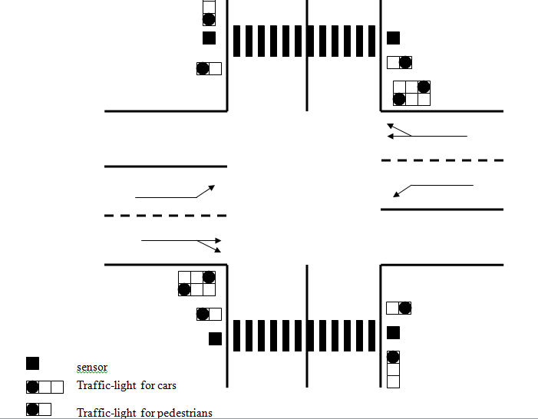

Crossing Type 2 in cell (1st row 2nd column

# Description:

This is the part of running application which will be given to tester for acceptance test. Tester are assign certain kind of task like adding/removing crossing, customize the traffic setting, maximize/minimize crossing etc. To make the test independent with each other task we already put some crossing in the grid.

Test Image A, B, C are same application but are in different state.

Before assigning specific task to tester, we will give some information on what and how the program should work.

Tester will also be provided with some pre-saved file.

# Test Action

**This test action are based on Use-Case and decision document we already made.**

Scenarios:

* Add crossing.
* Remove crossing.
* Start simulation.
* Maximize simulation.
* Adjust traffic.
* Save simulation.
* Open simulation.
* Stop simulation.
* New simulation,
* Show statistics
* Exit current simulation.

**NOTE- *The results of the actions are based on the pre created simulation test project as shown in the above pictures.***

|  |  |  |  |  |
| --- | --- | --- | --- | --- |
| **Action** | **Test case** | **Expectation** | **Success?** | **Remarks** |
| Add crossing (use test image A) | 1. Add crossing of type 2 in the grid   (Cell: 2nd row, 3rd column) | 🡺 System paints the type 2 crossing in that cell. | **yes** |  |
| 1. Add crossing of type 1 in the grid   (cell: 1st row, 3rd column) | 🡺System paints type 1 crossing in that cell | **yes** |  |
| 1. Add crossing of type 2 in the grid   (Cell: 2nd row 2nd column) | 🡺System shows error message” can’t put crossing” | **yes** |  |
| 1. Add crossing of type 1 in the grid   (Cell: 1st row, 4th column) | 🡺 System show error message” can’t put crossing”. | **yes** |  |
| 1. Add crossing without selecting cell | 🡺System show a message” No cell selected” | **yes** |  |
| 1. Perform adding while simulation is running | 🡺 show message” adding is not possible ” | **yes** |  |
| Remove crossing (use test Image A) | 1. Remove the crossing placed in grid   (Cell: 1st row, 4th column) | 🡺System removed the crossing at the selected cell. | **yes** |  |
| 1. Remove the crossing placed in grid   (Cell: 1st row, 2nd column) | 🡺System shows error message” selected cell doesn’t have crossing” | **yes** |  |
| 1. Remove items without selecting cell | 🡺System shows error message” no cell selected” | **yes** |  |
| 4. Perform removing while simulation is running | 🡺 show message” removing is not possible” | **yes** |  |
| Stop Simulation (use test image C) | 1. Stop Simulation while simulation is in running state | 🡺The simulation is stopped | **yes** |  |
| 1. Stop simulation while simulation is stopped | 🡺Nothing happens | **yes** |  |
| Maximize | 1. Maximize the size of crossing in grid (cell: 1st row, 4th column) | System opens panel & paints object with a bigger size. | **yes** |  |
| 1. Maximize the size of crossing in grid (cell: 1st row, 2nd column) | Nothing happen |  | Empty cell also maximize |
| Adjust Traffic (use test image B) | 1. provide the number of cars in crossing placed in grid( cell: 1st row, 4th column) | 🡺number of car provided is drawn in the crossing |  |  |
| 1. Increase the green time of traffic light. | 🡺timing of the traffic light is changed for provided lane  (can use show statistic, anytime, to be confirmed ) | **yes** | Number of green time is increased |
| 1. Try to change the number of car and green light timing for empty cell. | 🡺system shows the message “selected cell is empty “ | **yes** |  |
| 1. Give negative inputs for number of cars, green light timing, number of cars for traffic jam | System shows message “please check the input. numbers cannot be negative” | yes |  |
| 1. Change the values while simulation is running | System shows a message “change is not allowed while simulation is running” |
| Save Simulation (Use test image A) | 1. Save your work and give name “my first traffic save” | system gives message “successfully saved”  (Can use open simulation to get confirmed) | **YES** |  |
| 1. Save your work and give the name you already have in your folder i.e. again “my first traffic save” | System shows message” do you want to overwrite”. | **YES** |  |
| 1. Choose save option and click cancel | Save dialogue box closes and goes back to simulation | **YES** | Save option is disabled |
| 1. Save your work while simulation is running | 🡺system shows message “not allowed, simulation is running” |
| Open Simulation (use pre-saved file) | 1. Open the application and Open the pre-saved file | 🡺System opens file and paints all the crossing in the grid | **YES** |  |
| 1. Try to open the file with the format “*.jpeg”. | 🡺System shows an error message “cannot open.” | **YES** | Error message |
| 1. Chose a file that is already opened in the application | 🡺System shows message “File already opened” |  |  |
| 1. Open saved file while simulation is running | System shows a message “changes is not allowed.” |  | Open is disabled |
| New | 1. create new project | system show new simulation grid to work |  |  |
|  | 1. Create new project without closing pre-opened file | System shows message “do you want to save current project?” |  |  |
| 1. Create a project while simulation is running | System shows a message “Change is not allowed while simulation is running.” |
| Exit | 1. close the program   while simulation is in stopped state | Case 1: System close application if all ok  Case 2: if changes made not saved, user shows message” do you want to save? ”User choose “No”. System close the application and user chose” Yes”, goes to save case. |  |  |
| 1. Close the program while simulation is running | System shows the message” simulation is running currently. Please stop the simulation before closing” |  |  |

|  |  |  |  |  |
| --- | --- | --- | --- | --- |
| **Action** | **Test case** | **Expectation** | **Success?** | **Remarks** |
| Start simulation (use image c and maximize view of crossing) | 1. Start simulation  (Lighting system crossing type 1) | * Simulation is running. * The group 1(lane 1,2,8,9) Traffic light is Green * The Other lights are red * The group 1 light turns red and group 2(i.e. lane 5,6,10,11) gets green * The other lights are still red * Waits for group 2 light to be red * The lights at lane12, 4, 1 will be green, and the other lights will be red * Light at lane 3, 7, 6 will be green * Other lights will be red * Light at lane 1, 2, 8,9 will be green and the other lights will be red | **YES** | All the lights work correctly |
| Start simulation | 2.Start simulation  (Car Movement with lighting system, type1) | * Light at lane 1 is green * Car at lane one is moving * Light at lane 9 is green and car at lane 9 is moving * Light at lane 5 and 6 is red * Car at lane 5and 6 are stopped * Wait 20 sec(or time set by user) * Light at lane 1 is red * Car at lane 1 has stopped moving * Light at lane 9 is red and car at lane 9 have stopped moving * Light at lane 5 and 6 is changed to green and car at lane 5 and 6 has started to move * car is moving in correct direction without overlapping each other * cars is divided in certain ratio before entering the new crossing |  |  |
| Start simulation | 3. Start simulation  (Lighting system crossing type 2) | * The Traffic light at Lane L5+L11+Pedestrain-1+ pedestrian-2 will be green * The Other lights will be red * Waits for 20 sec(or time set by user) * the lights at lane 1,2,8,and 9 will change to green * The Light at lane L5+L11+Pedestrain-1+ pedestrian-2will be changed to red * The other lights will be still red * Waits for 20 sec * The lights at lane 5,6,10,11 will be changed to green * the lights at lane 1,2,8,and 9 will be changed to red * The rest of light will still be red * Waits for 20 sec * The lights at lane 5,6,10,11 will be changed to red * The lights at lane 12,4,1 will be changed to green * The rest of light will still be red * Waits for 20 sec * The lights at lane 12,4,1 will be changed to red * The lights at lane 3,7,6 will be changed to green * The rest will remain red * Waits for 20 sec * The Traffic light at Lane L5+L11+Pedestrain-1+ pedestrian-2 will be green * The Other lights will be red | **YES** |  |
| Start simulation | 4.Start simulation  (Car Movement with lighting system, type2) | * Light at lane 5 is green * Car at lane 5 is moving * Light at lane 11 is green and car at lane 11 is moving * Light at lane 1 and 2 is red * Car at lane 1 and 2 are not moving * Waits 20 sec * Light at lane 5 is changed to red * Car at lane 5 has stopped moving * Light at lane 11 is changed to red and car at lane 11 has stopped moving * Light at lane 1 and 2 is red * Cars at lane 1 and 2 have started moving | **YES** | Mostly all the cars are following the light |
| Start simulation | Start simulation  (pedestrian movement type-II) | * Pedestrian 1 and pedestrian 2 lights are green * Pedestrian 1 and 2 are moving * Light at lane 5 is green * Car at lane 5 is moving * Light at lane 11 is green and car at lane 11 is moving * The rest of lights are red and the rest cars are stopped * Waits 20 sec(or time set by user) * Pedestrian 1 and 2 lights are red * Pedestrian 1 and 2 stopped moving | **YES** |  |